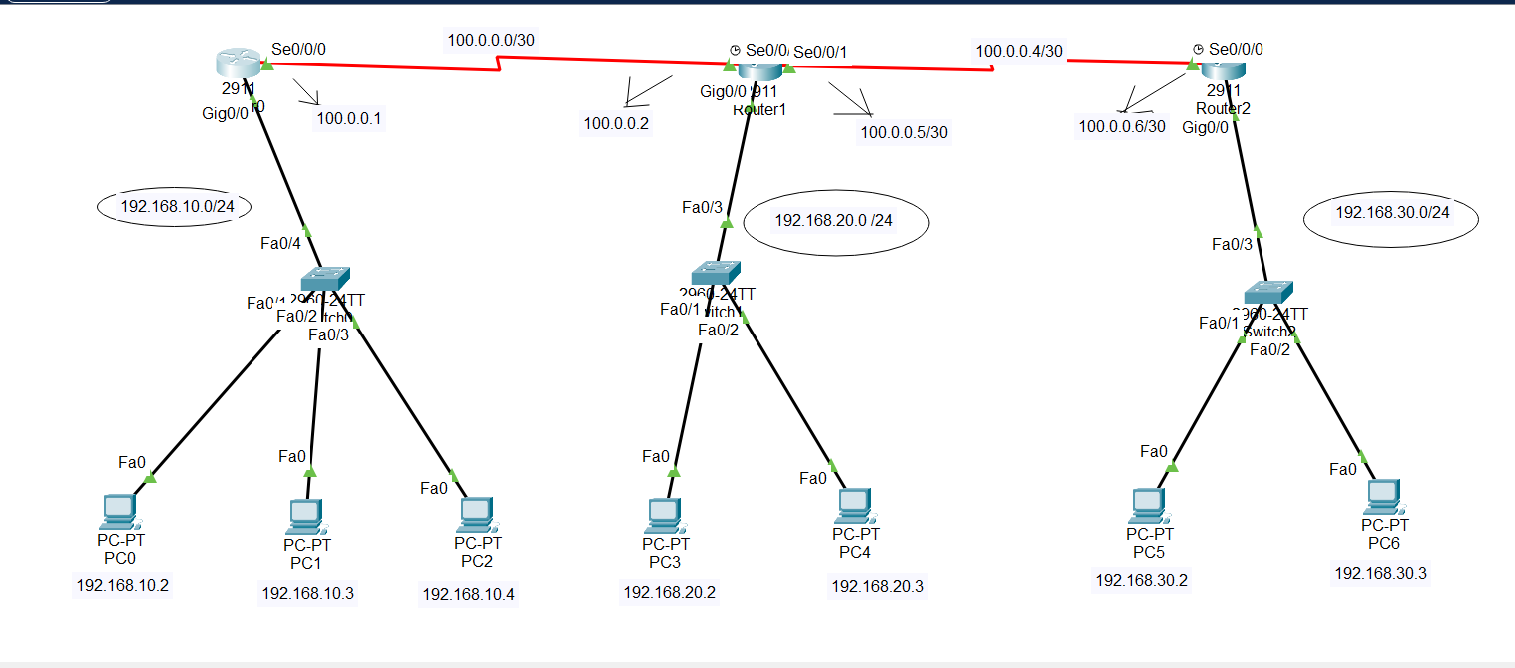

**In router 0:**

**Step1:**

Router>enable

Router#configure terminal

**Step2:**

Router(config)#int gig0/0

Router(config-if)#no shutdown

Router(config-if)#ip address 192.168.10.1 255.255.255.0

Router(config-if)#exit

**Step3:**

Router(config)#int se0/0/0

Router(config-if)#no shutdown

Router(config-if)#ip address 100.0.0.1 255.255.255.252

Router(config-if)#exit

**Step4:**

Router(config)#ip dhcp pool mypool

Router(dhcp-config)#network 192.168.10.0 255.255.255.0

Router(dhcp-config)#default-router 192.168.10.1

Router(dhcp-config)#dns-server 0.0.0.0

Router(dhcp-config)#exit

**Step5 : ( static routing command)**

Router(config)#ip route 192.168.20.0 255.255.255.0 100.0.0.2 { know 192.168.20.0 network}

Router(config)#ip route 192.168.30.0 255.255.255.0 100.0.0.2 { know 192.168.30.0 network}

Router(config)#ip route 100.0.0.4 255.255.255.252 100.0.0.2 { know 100.0.0.4 network}

**In router 1:**

**Step1:**

Router>enable

Router#configure terminal

**Step2:**

Router(config)#int gig0/0

Router(config-if)#no shutdown

Router(config-if)#ip address 192.168.20.1 255.255.255.0

Router(config-if)#exit

**Step3:**

**{a}**

Router(config)#int se0/0/0

Router(config-if)#no shutdown

Router(config-if)#ip address 100.0.0.2 255.255.255.252

Router(config-if)#exit

{b}

Router(config)#int se0/0/1

Router(config-if)#no shutdown

Router(config-if)#ip address 100.0.0.5 255.255.255.252

Router(config-if)#exit

**Step4: (DHCP ip assign)**

Router(config)#ip dhcp pool mypool

Router(dhcp-config)#network 192.168.20.0 255.255.255.0

Router(dhcp-config)#default-router 192.168.20.1

Router(dhcp-config)#dns-server 0.0.0.0

Router(dhcp-config)#exit

**Step5 : ( static routing command)**

Router(config)#ip route 192.168.10.0 255.255.255.0 100.0.0.1 { know 192.168.10.0 network}

Router(config)#ip route 192.168.30.0 255.255.255.0 100.0.0.6 { know 192.168.30.0 network}

**In router 2:**

**Step1:**

Router>enable

Router#configure terminal

**Step2:**

Router(config)#int gig0/0

Router(config-if)#no shutdown

Router(config-if)#ip address 192.168.30.1 255.255.255.0

Router(config-if)#exit

**Step3:**

Router(config)#int se0/0/0

Router(config-if)#no shutdown

Router(config-if)#ip address 100.0.0.6 255.255.255.252

Router(config-if)#exit

**Step4:**

Router(config)#ip dhcp pool mypool

Router(dhcp-config)#network 192.168.30.0 255.255.255.0

Router(dhcp-config)#default-router 192.168.30.1

Router(dhcp-config)#dns-server 0.0.0.0

Router(dhcp-config)#exit

**Step5 : ( static routing command)**

Router(config)#ip route 192.168.10.0 255.255.255.0 100.0.0.5 { know 192.168.10.0 network}

Router(config)#ip route 192.168.20.0 255.255.255.0 100.0.0.5 { know 192.168.20.0 network}

Router(config)#ip route 100.0.0.0 255.255.255.252 100.0.0.5 { know 100.0.0.0 network}

## if I want to undo the static routing then command:

For router 0:  
**Router(config)#no ip route 192.168.20.0 255.255.255.0 100.0.0.2**

**Router(config)#no ip route 192.168.30.0 255.255.255.0 100.0.0.2**

**Router(config)#no ip route 100.0.0.4 255.255.255.252 100.0.0.2**

For router 1:  
**Router(config)#no ip route 192.168.10.0 255.255.255.0 100.0.0.1**

**Router(config)#no ip route 192.168.30.0 255.255.255.0 100.0.0.6**

For router 2:

**Router(config)#no ip route 192.168.10.0 255.255.255.0 100.0.0.5**

**Router(config)#no ip route 192.168.20.0 255.255.255.0 100.0.0.5**

**Router(config)#no ip route 100.0.0.0 255.255.255.252 100.0.0.5**